Errors

Adding jenkins to sudoers file

sudo visudo

jenkins ALL=(ALL) NOPASSWD:ALL

Testing jenkins user

sudo -u jenkins -i

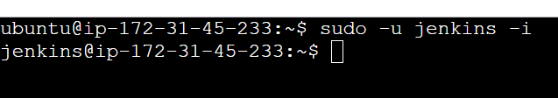

Changing the default editor to vi

sudo update-alternatives --config editor

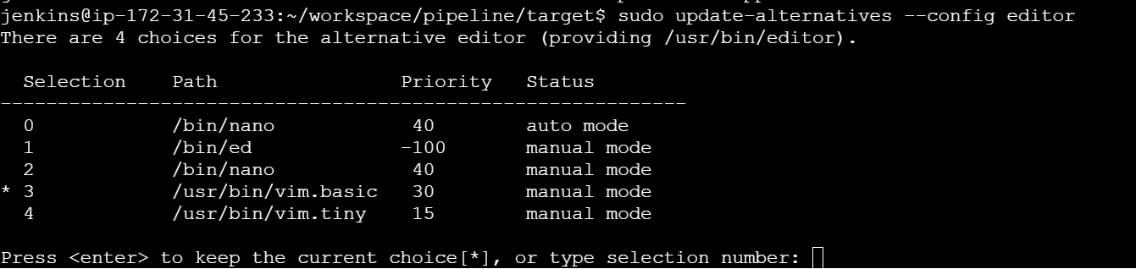

Installing docker plugins

To run docker commands we need to install docker plugins in jenkins

Adding jenkins user to docker group

sudo usermod -aG docker jenkins

newgrp docker

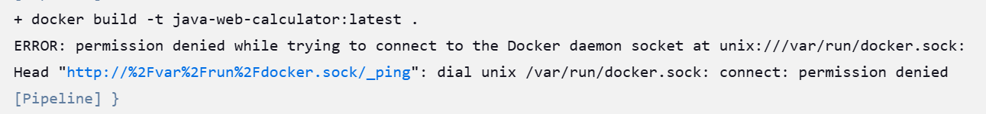

sudo usermod -aG docker jenkins

sudo systemctl restart jenkins

sudo -u jenkins docker info

ls -l /var/run/docker.sock

srw-rw---- 1 root docker 0 Jan 11 14:12 /var/run/docker.sock

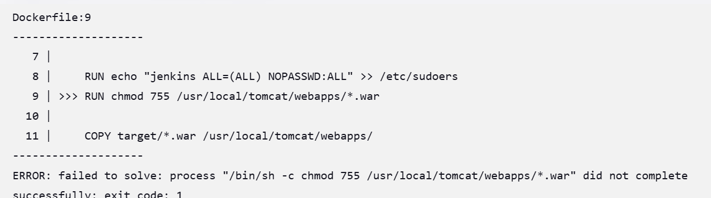

The error you're encountering happens because the chmod command is trying to apply permissions to a .war file in the /usr/local/tomcat/webapps/ directory, but the file is not present at that point in the Docker build process.

# Use the official Tomcat image

FROM tomcat:9-jdk17

# Create the Jenkins user and add it to sudoers

RUN useradd -ms /bin/bash jenkins

RUN echo "jenkins ALL=(ALL) NOPASSWD:ALL" >> /etc/sudoers

# Copy the WAR file from the target directory into Tomcat's webapps folder

COPY target/*.war /usr/local/tomcat/webapps/

# Apply permissions to the copied WAR file(s)

RUN chmod 755 /usr/local/tomcat/webapps/*.war

# Ensure Jenkins user owns the necessary files

RUN chown -R jenkins:jenkins /usr/local/tomcat/webapps

# Expose the Tomcat default port

EXPOSE 8080

# Start Tomcat

CMD ["catalina.sh", "run"]

TAG = "${BUILD_ID}"